# Carousel Monitor Control 1.0.0 Documentation

Overview

Carousel Monitor Control is a system tray application that allows the user to schedule a monitor to power on and off. It can control the power state by wither using Windows power management technology, or by issuing a command via the serial port. The application allows you to have 4 power events per day, two on events and two off events.

Installing the application

Carousel Monitor Control is a Microsoft Windows 32 bit application. It requires Microsoft .Net Framework 2.0 or higher. To install the application run *‘Carousel Monitor Control 1.0.0.exe’* on the target machine. The installer will place the runtime files in your target directory and install a shortcut to the system tray application in the startup folder. It will also launch the application at the end of the install process.

Because the application runs in the system tray, it requires that a user be logged into Windows for it to run. Carousel Monitor Control does not currently run as a service.

System tray menu

Carousel Monitor Control appears in the lower-right corner of your screen. Right-clicking on the icon brings up the menu.

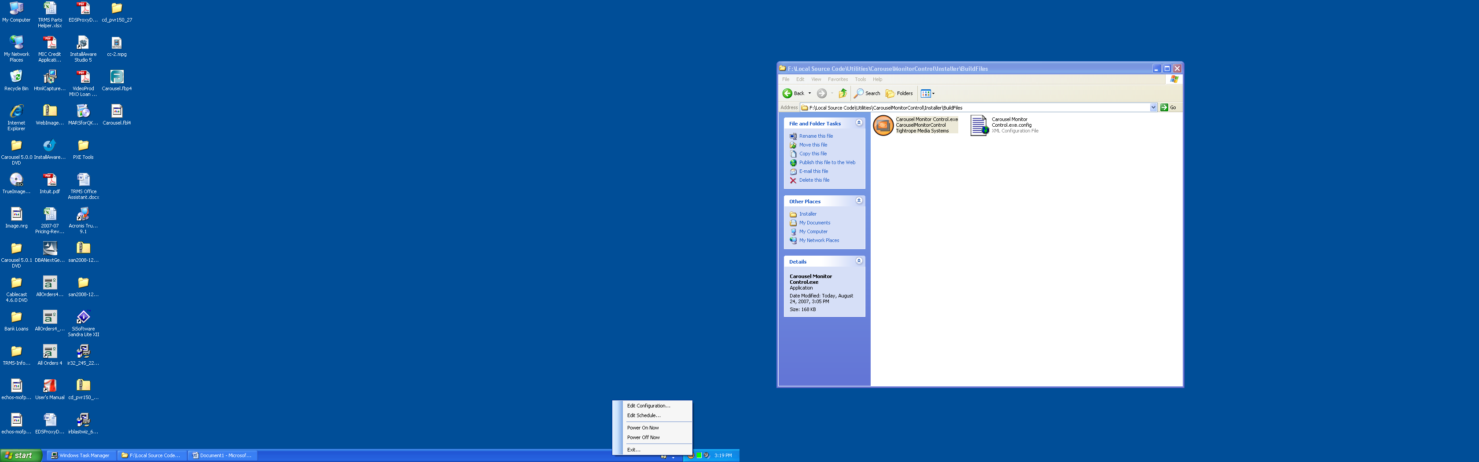The *‘Edit Configuration…’* menu allows you to adjust the power on and off type.

The *‘Edit Schedule…’* menu allows you to change when the monitors power on and off.

The *‘Power On Now’* menu powers the monitor on based on the current configuration.

The *‘Power Off Now’* menu powers the monitor on based on the current configuration.

Edit Configuration

There are two options for powering on and off the monitors.

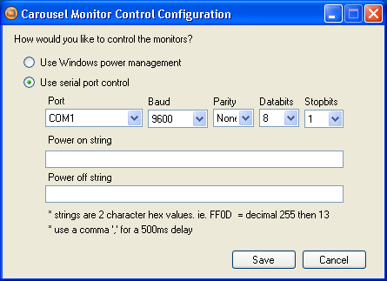The *‘Use Windows power management’* method uses the power management features built into Windows. This is the same technology that puts your monitor to sleep after an hour of no activity. Some LCD and Plasmas do not respond to these commands like a desktop display would.

The *‘Use serial port control’* method sends data out the serial port to control the monitor. This can be used for displays that do not work properly with Windows power management and have a serial port with an available protocol.

The Carousel Monitor Control application does not come with predefined control codes for monitors for serial control. It is the responsibly of the installer to find the codes for the particular display they are controlling. *Tightrope cannot provide assistance finding codes or programming for specific displays.*

The *‘Power on string’* and *‘Power off string’* are fields in which to enter the codes take hexadecimal notation. Strings are 2 character hex values. For example, FF0D = decimal 255 then 13. Use a comma ',' for a 500ms delay between characters.

Example strings

Send the characters ‘ON’, wait 1 second, and then send a carriage return.

Power on string: *F44E,,13*

Send the characters ‘OFF’, wait 1 second, and then send a carriage return.

Power off string: *F44646,,13*

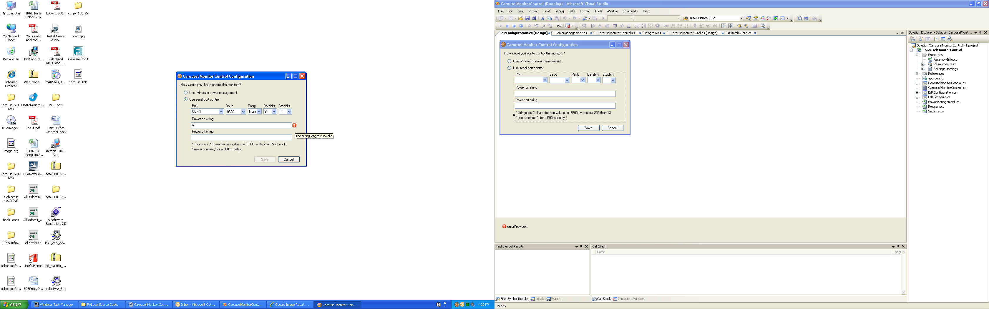The *‘Power in string’* and *‘Power off’* strings will check if you have entered an invalid string. If so, it will alert you. To see the alert message mouse-over the alert icon. Furthermore, it will alert you about any non-hexadecimal characters.

Edit Schedule

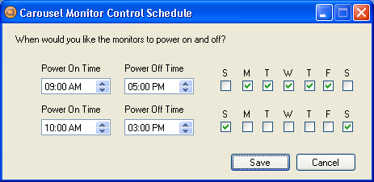There are two available schedules in the application. They are time and weekday based. The *‘Power On Time’* and *‘Power Off Time’* events will occur on the weekdays selected for that schedule.

If the *‘Power On Time’* is later than the *‘Power Off Time’* the application will assume that event spans midnight and will offset the day appropriately. For example, if you tell the application to power on at 10:00 PM and power off at 3:00 AM on Saturday. The monitor will power on at 10:00 PM on Saturday and power off at 3:00 AM Sunday.

ASCII Chart

